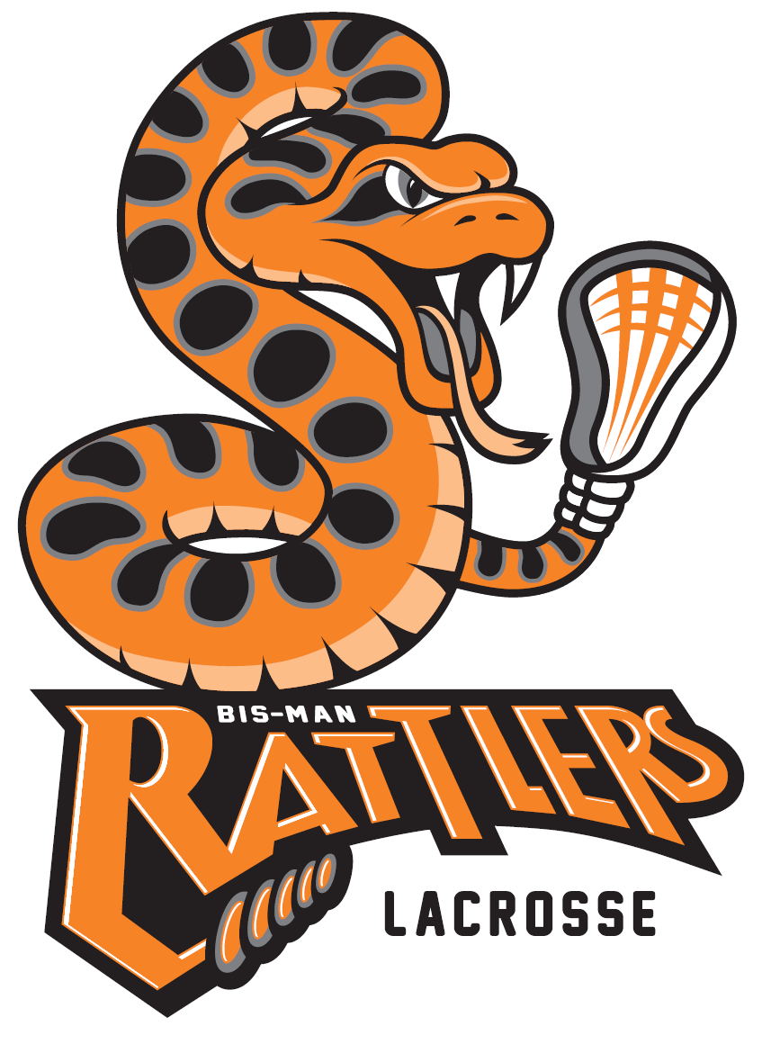
Bismarck Mandan Lacrosse Association Sponsorship
www.bismanlacrosse.org

Dear Prospective Bismarck Mandan Lacrosse Sponsor:
As we look forward to the 2024 lacrosse season in the Bismarck-Mandan area, we wish to form a partnership with you, the community sponsors.
The Bismarck Mandan Lacrosse Association (BMLA) is a 501(c)(3) non-profit organization promoting the sport of lacrosse to the youth in the Bismarck‐Mandan area. The mission of BMLA is to foster a life‐long enjoyment for the game of lacrosse, through the developmental programs for youth boys and girls, ages 6 through high school. Programs include teaching individual skills, the essentials of team play, proper physical conditioning, and most importantly, good sportsmanship. BMLA encourages players to develop a positive attitude, self‐discipline, respect for others, and commitment to the success of their team and organization.

Part of our goal in raising funds for the lacrosse program is to make participation in the sport of lacrosse affordable, especially with the increase costs nationwide. We feel that encouraging local business support of education and athletics through advertisement or donations will help foster a sense of community pride and ownership. Through this sponsorship, you will be benefiting the lacrosse program and all the youth athletes in our community.

The attached sponsorship order form will give you information on the costs of participating in our sponsorship program and becoming a part of the fastest growing sport on two feet.
We ask for you to consider a sponsorship, and depending on your level of commitment, would include listing your business/logo on our lacrosse website and host weekend banner recognition. With your support, we will strive to reach our goal of establishing a program based upon academic excellence, sportsmanship, and dedication.
We truly appreciate your time and thank you in advance for supporting the Bismarck Mandan Lacrosse Association Program. If you have any questions, you may email Kyle Mund batman@bis.midco.net or call me at 701-400-5700.
Warmest Regards,
Kyle Mund
Kyle Mund, Board Member
Bismarck Mandan Lacrosse Association
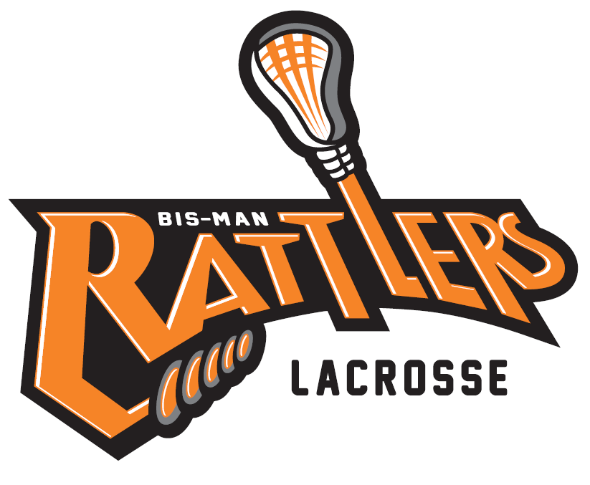
Bismarck Mandan Lacrosse Association
2024 Sponsorship Form
SPONSOR INFORMATION
Company Name:
Street Address: City / State / Zip:
Mailing Address: City / State / Zip:
SPONSORSHIP LEVEL
$ 2,000 Jersey Sponsor $ 500 Pinnie Sponsor
$ 200 Field Sponsor $ ________ Operating Sponsor
Checks made payable to: Bismarck Mandan Lacrosse Association
CONTACT INFORMATION
Contact Name: Phone Number:
Email address: Web Site:
NOTES/SPECIAL REQUESTS

Check No: Amount of Check: $ Date of Check:
Logo must be emailed by the due date listed in the sponsorship levels to Bismanlax@gmail.com and Kyle Mund batman@bis.midco.net
Sponsorships are non-refundable

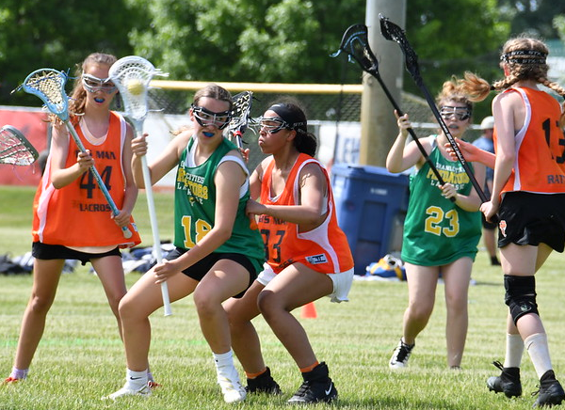
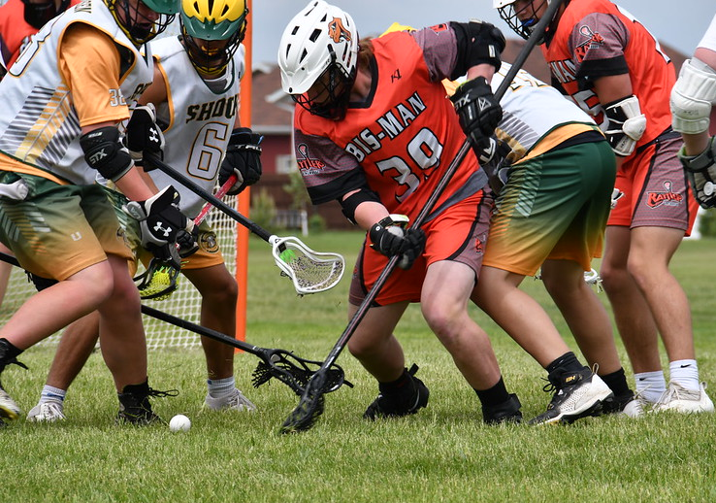
Levels of Sponsorship:
All Sponsor levels include:
- Business Name and Logo displayed on BMLA Website.
- Reoccurring Business Name and Logo displayed on BMLA Facebook.
- Business Name and Logo displayed on host weekend banner and program.

Jersey Sponsor $2,000
- Business name and/or logo printed on team jersey. **
- Deadline January 8, 2024.

Pinnie Sponsor $ 500
- Business name and/or logo printed on the pinnie given to each athlete for game nights. **
- Deadline March 29, 2024.

Field Sponsor $ 200
- Business name and logo printed on field signage at host weekend.
- Deadline April 15, 2024.

Operating Sponsor $ _____
- Any monetary sponsorship of your choice that will be used for operating costs of
league fees, official expenses, athletic trainer, and travel costs.
- Deadline April 15, 2024.

** Clothing items could contain multiple business names depending on the number of sponsors.
Please make checks payable to: Bismarck Mandan Lacrosse Association
PO Box 193
Bismarck, ND 58502-0193
701-400-5700 (Kyle Mund)

